**FAST- NATIONAL UNIVERSITY OF COMPUTER AND EMERGING SCIENCES**

**Database Systems**

**SCHOOL MANAGEMENT SYSTEM**

**PROJECT REPORT**



**Group Members:**

**K18-1078 Oneeba Ahsan (Section C)**

**K18-1362 Yasir Obaid (Section C)**

**K18-0243 Usama Bin Ejaz (Section C)**

**INTRODUCTION AND DESCRIPTION:**

The system automates the school management activities.   
- Admin can view the enrolled students and their details.  
- Admin can view and assign classes to teachers   
- With the help of this system, admin can allocate any free teachers as "substitute" if required.   
- The system generates a fee voucher against each student's ID on each month and hence eliminating the need of keeping manual receipts.  
- The system is convenient and flexible to be used.  
- The system is efficient and saves time, money and resources

Front End/Back End technology:

Visual Studio {ASP.NET(Html) and C# backend, Using MySQL for Database on MySQL Workbench

**NORMALIZATION:   
  
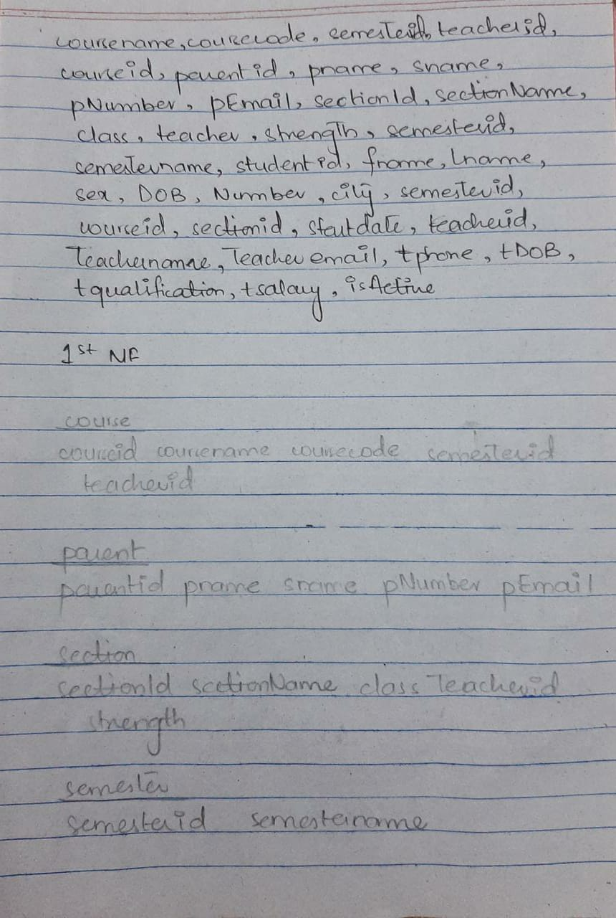**

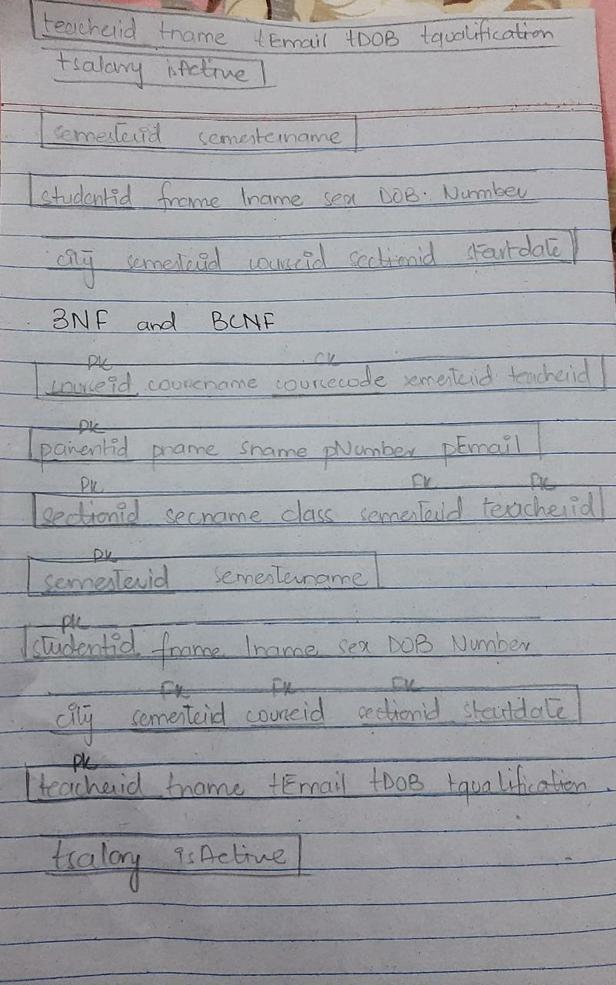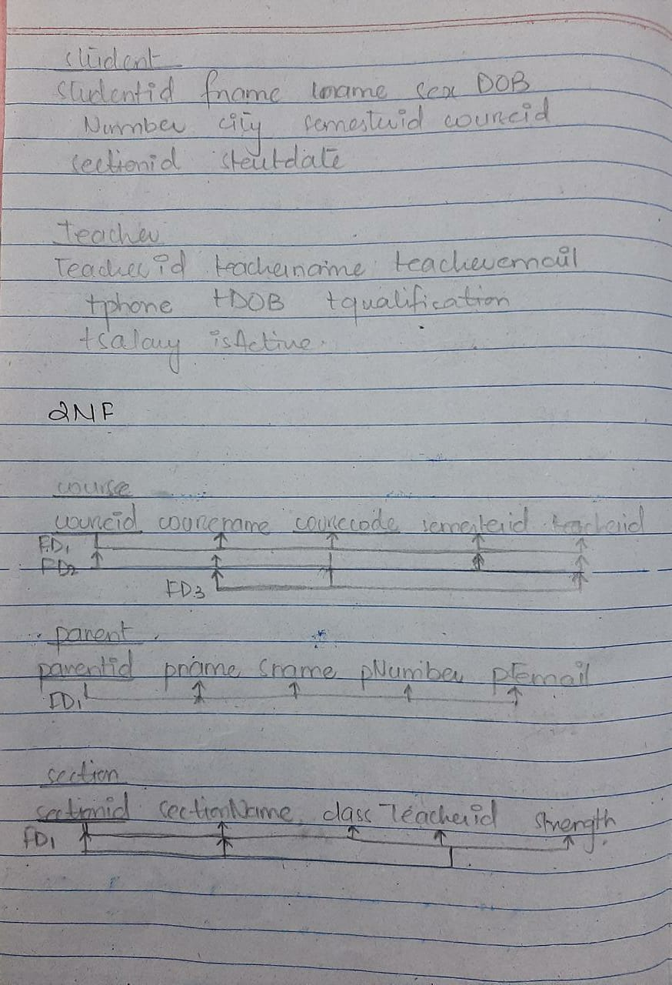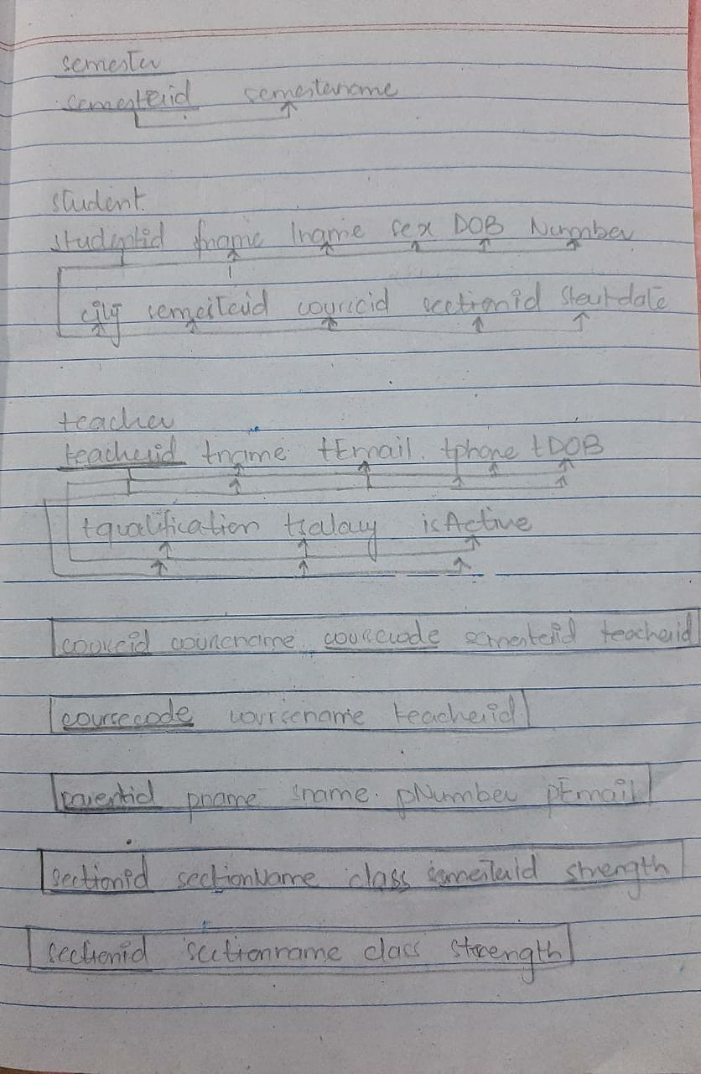

**ENTITY RELATIONSHIP DESIGN:**

**Entities:**

1. Student:

The student who is linked with all other entities via keys and other information

1. Admin

The administrator of the system who adds the students, manages the system and teachers and courses, Basically everything. Currently hardcoded can be added with the teacher / staff list later on when we increase the system.

1. Parent

The parents of the students

1. Teacher

Teachers being assigned to the courses and sections currently teaching in the institute

1. Courses

The Courses for a particular semester, Multiple courses per semester getting assigned to multiple students and taught by multiple teachers

1. Semester

The current semester containing the fix number of multiple courses

**ER Diagram:  
  
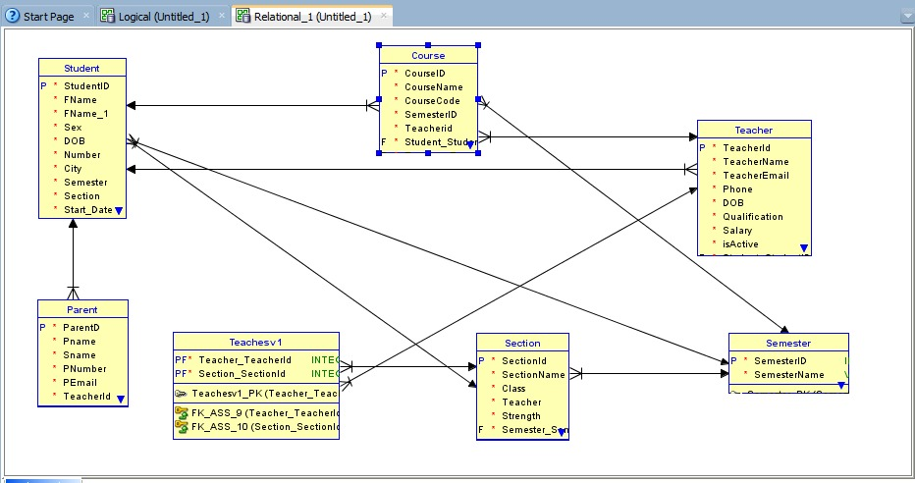  
  
  
Implementation phase and Pictures:**   
  


